# **Introduction**

1. **Introduction**

We made stunning and informative visualizations and dashboards in previous sessions. Now we have to share and provide required access to this information to necessary people to optimize their decision-making process anywhere they needed either from access by PC or mobile device. Here comes Microsoft Power BI Pro and Microsoft Power BI Mobile

At the start of this module, we will focus on the following titles.

* Understanding the Power BI Pro
* Publishing and Workspace
* Understanding Dashboard
* Understanding Power BI Gateway
* Understanding the relationship between Power BI Desktop and Power BI Pro
* Understanding the Workspaces, Sharing, and Project Collaboration
* Sharing data between Power BI Desktop, Pro, and Mobile
* Power BI Apps

Without further ado let’s dive in.

1. **Power BI Desktop Vs Power BI Pro**

With the scattered and limited data provided by our client, we manage to create very stunning and informative reports. But unfortunately, those reports are limited to our local PC, we can stop from here but this is not the way of true business intelligent application works. We must disseminate the knowledge we acquired from the analysis to the people who are capable of utilizing that knowledge to become Intelligent

We need an additional component in the Microsoft Power BI framework called Power BI Pro. This is a cloud application allows that users to publish Knowledge within the Power BI desktop project allowing required people to access the required information from anywhere in the world with a computer and internet connection

Power BI Mobile

Microsoft Power BI

Power BI Pro

Single User

Done



Data Analyst

Publish

Mobile Access

Organization

Microsoft Power BI

Power BI Pro



Data Analyst

IT/Developers

Power BI Pro

Share

Power BI Mobile

Marketing



Publish

Mobile Access

In the initial stage, we start with single user environment and, as we progress through the session we see how we can get data from PBI Desktop to PBI Pro then we address the other important sections as we progress

# **Getting Started**

1. **Power BI Pro Pricing**

As I mention before Power Bi pro is a cloud service and like all Microsoft Cloud services there is a price tag attached to this service too. This link provides the pricing option for Power BI Pro <https://powerbi.microsoft.com/en-us/pricing/> Make sure to review the pricing because pricing may change based on time and geographical location. The Current pricing options I can see as below

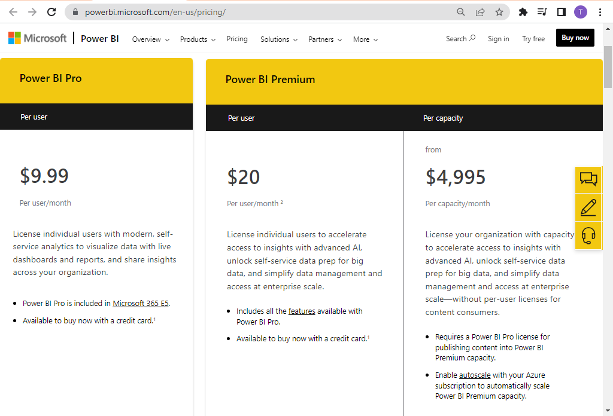

Here we are focused on learning about Power BI Desktop, Pro, and Mobile, so we can forget Power BI Premium because it is for large organizations and complex use cases. You must have a company email address to sign up for Power BI Pro otherwise you will get the below message

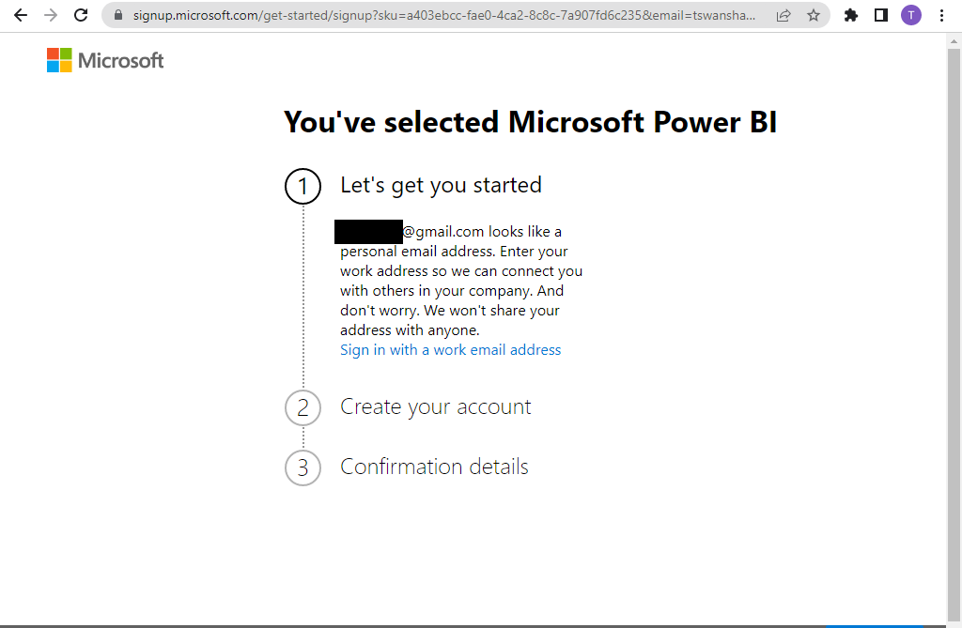

1. **Setting up Microsoft Power BI (Optional)**

If you have a company email address you can start a free trial for Power BI Pro for this session to start a free trial click the free trial button at the right-hand corner of the webpage

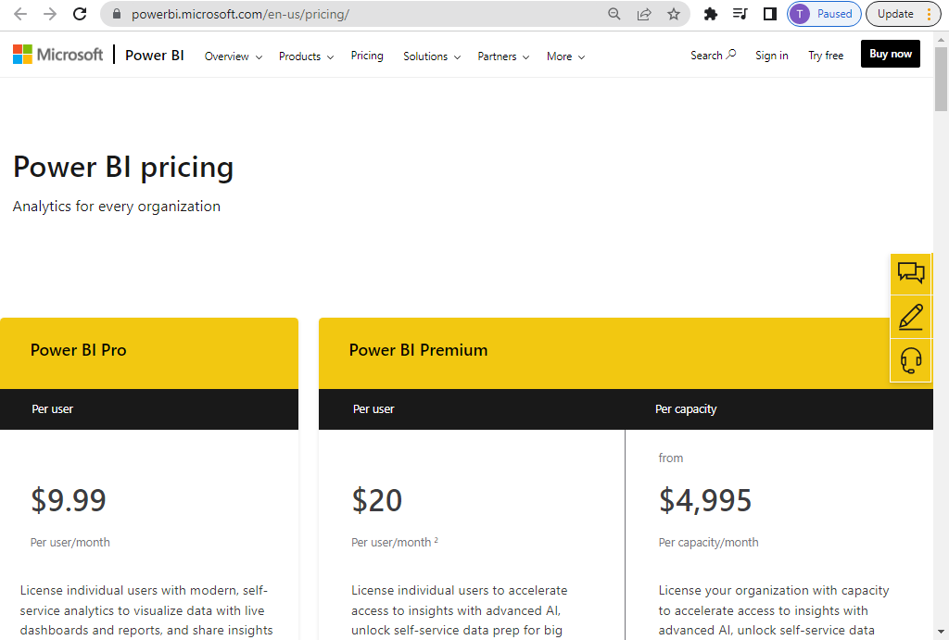

Follow the instructions provided by the Web page and provide the required information and soon you will be on this page that means you are successful at creating a Power BI Pro account and now you are ready to explore the capabilities offered by Microsoft Power BI Pro and Power BI Mobile

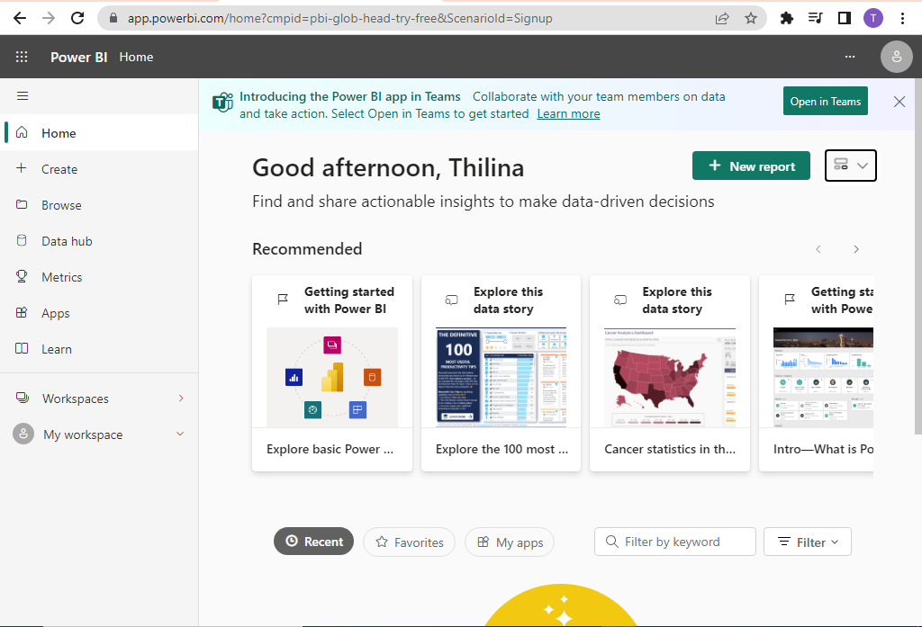

Profile

General Settings Area

Show/Hide Navigation Pane

Navigation Pane

Like the previous session I will not explain every function on the screen at the start of the session we will learn each feature as we progress through the lessons. So hang tight and let’s start the journey.

# **Publishing Power BI Reports**

1. **Publishing Report**

Well, this seems straightforward forward click the new report and we can publish our adventure works reports isn’t it, not quite. When you click the New Report button. You will direct to Create Page of Power BI Pro and there we click Pick Published Dataset you will direct to this page

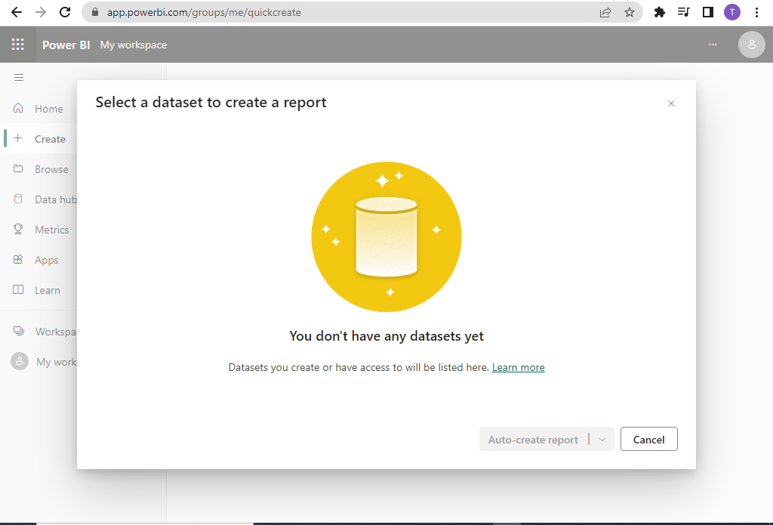

Well, When we check the Data Hub page we have the same issue so it seems we have other additional steps to follow. The solution for the above problem is we have to create the link between the dataset in the Power BI Desktop to Power BI Pro and there are two ways to do this

* Connect Power BI Pro to Power BI Desktop Data Model
* Publish Power BI Desktop Data Model and Utilize it from PBI Pro

Power BI Desktop

Publish

Connect

Power BI Pro(Cloud)

We have to utilize both PBI Desktop and PBI Pro to create an effective BI framework because PBI Desktop is lack disseminating intelligence and PBI Pro Lack of Query Editing capabilities when we get the required Dataset to PBI Pro these data will be stored in a dedicated controllable environment called “**Workspace**”. Next session we see how to

1. **Workspace**

Each user in your organization who have access to PBI Pro services has dedicated storage in the cloud. Any user can access this storage via the “My Workspace” section in the Power BI Pro user can store datasets, reports, and dashboards in the personal workspace and then give access to resources and share them as needed. This workspace concept allows greater accessibility and collaboration and improves security

Let’s connect our Power BI Desktop project made before to the Power BI Pro Via Workspace

* Click On my workspace and then click upload

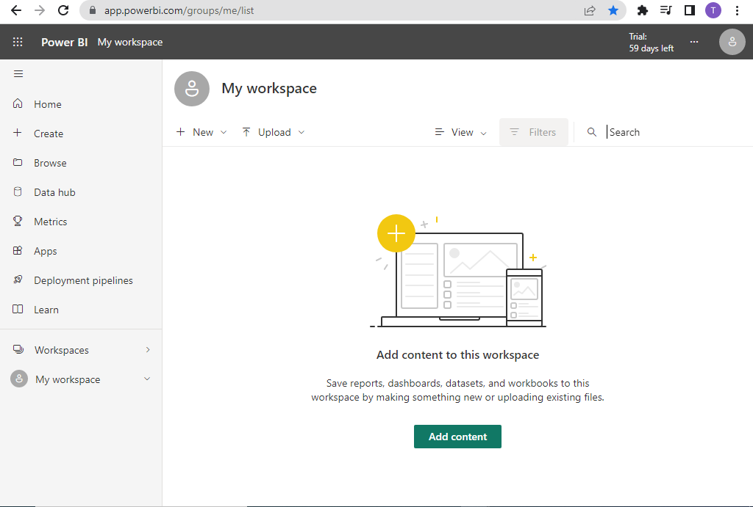

* Find the Power BI Desktop Project file (.pbix) file and click open. This may take a few seconds to upload into Power BI Pro and at the end you will get the below screen successful

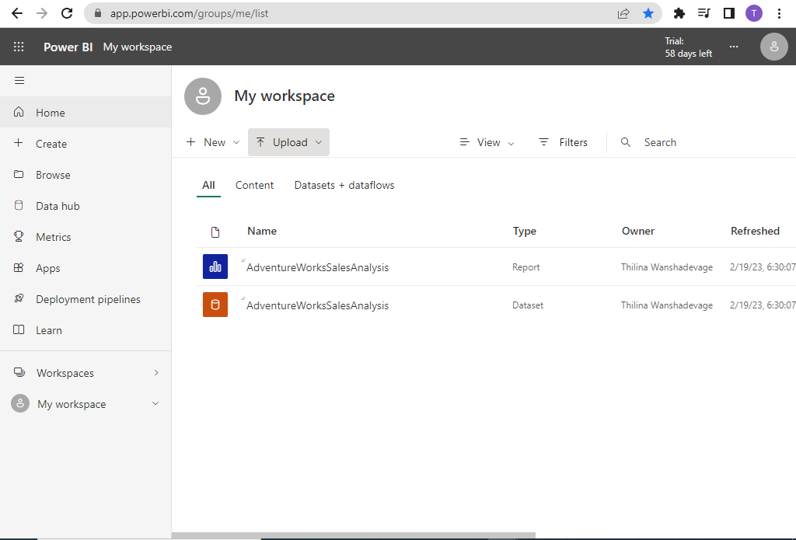

* As I explained before this is one way of linking PBI Desktop to PBI Pro by connecting PBI Pro to the PBI Desktop project if you are working on PBI Pro currently
* Next, we will see how we can publish reports from Power BI Desktop to Power BI Pro

1. **Publishing Reports from Power BI Desktop to Power BI Pro**

* Login to Power BI Desktop With Power BI Pro Credentials
* Go to Power BI Desktop->Home->Publish

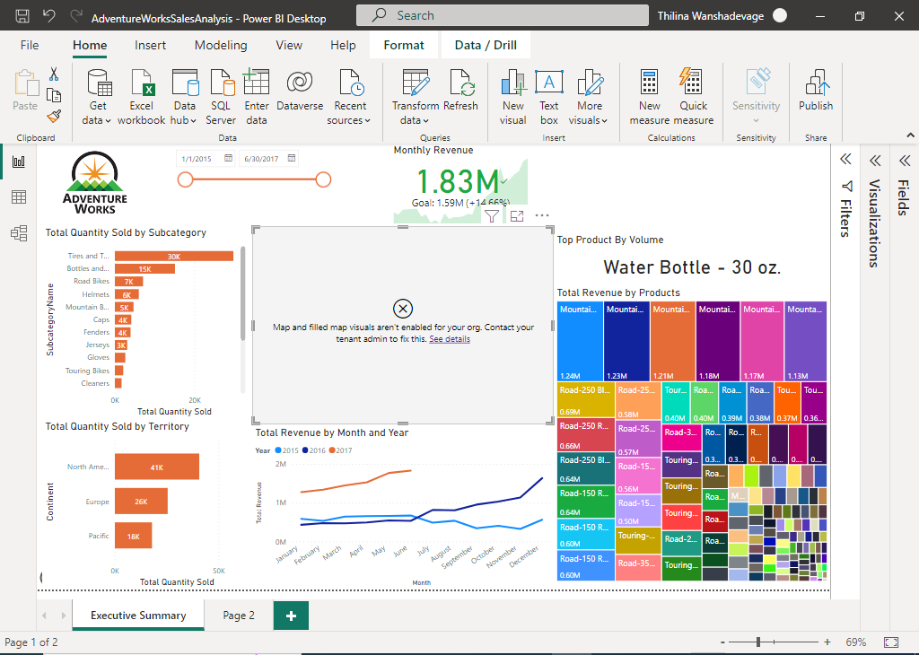

* Select ‘My Workspace’ From the List and Click the Select button

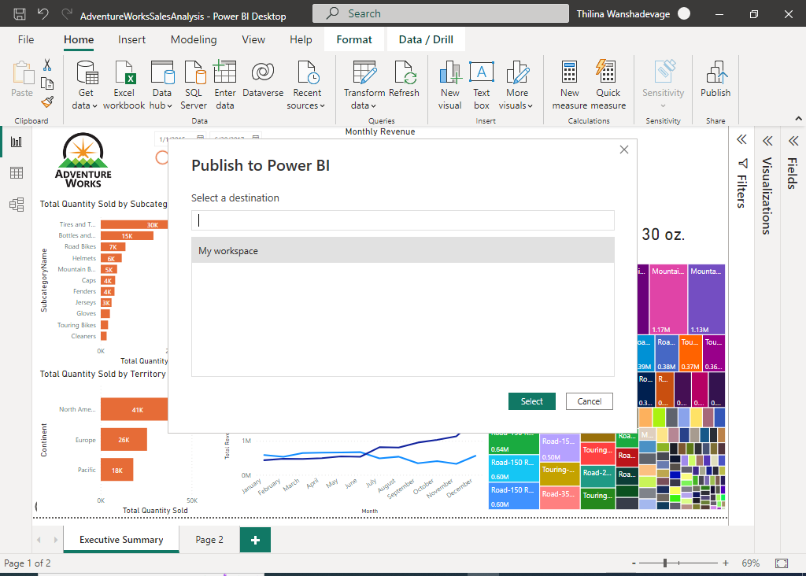

* It may take a few minutes but if you get this message at the end publishing is happen from the Power BI Desktop end

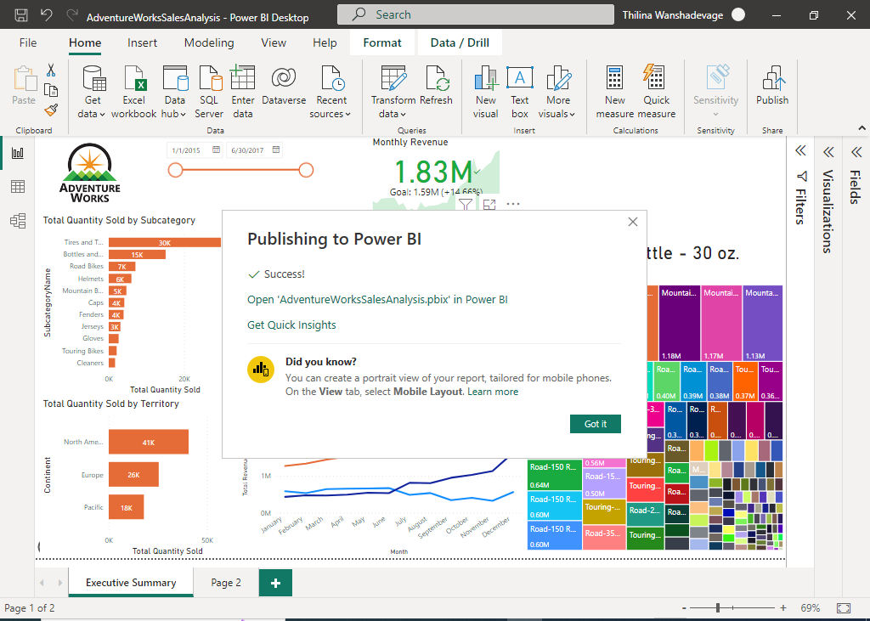

* If we go to Power BI Pro and refresh the page we will get the following screen.

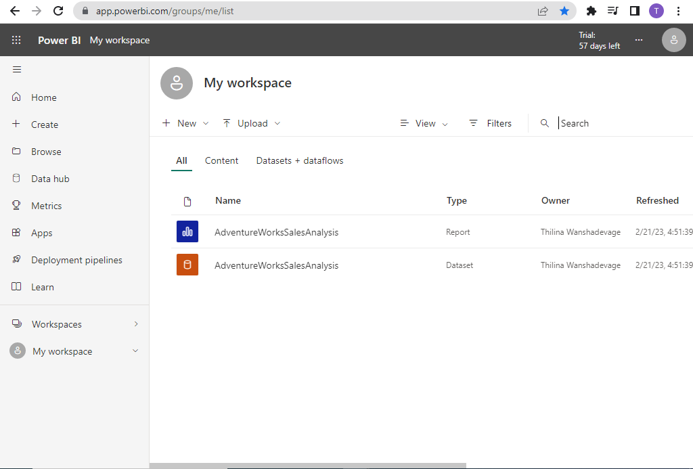

* It may take some time to configure and show up Power BI adventure works dashboard

# **Workspace Basics**

1. **Power BI Dataset** 
   * Go to Power BI Pro->My Workspace->Dataset->AdventureWorkSales, following page will load into a browser
   * This page contains the information about selected dataset

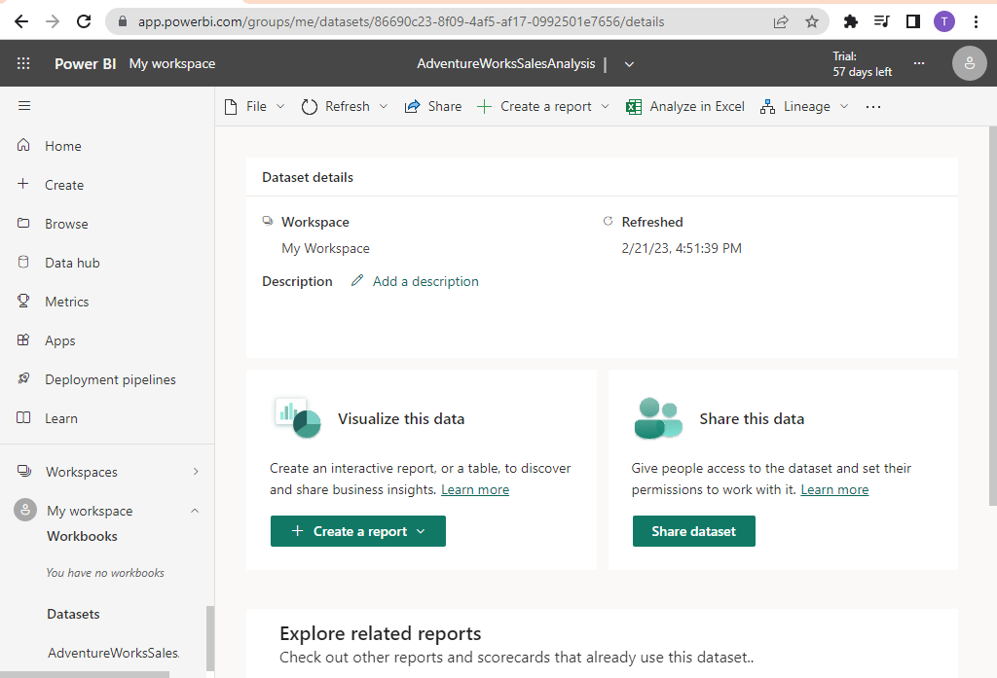

* + If You click the Three dot sign marked at the end of the PBI Pro Screen->Show Tables Will change to the following view with added table section.

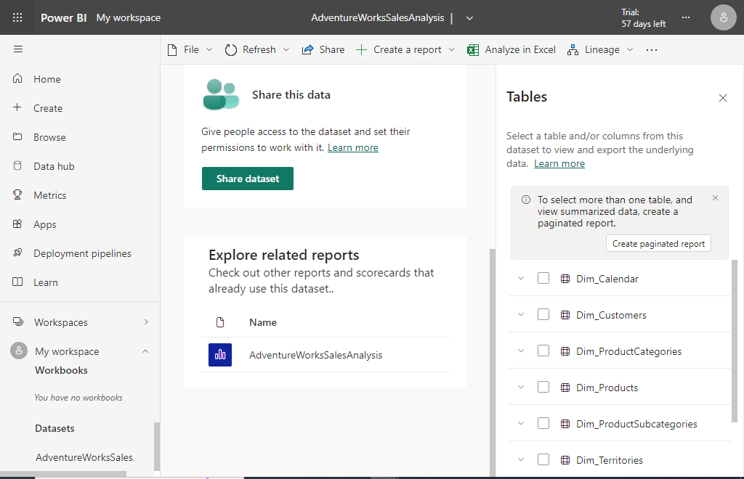

* + Here we can expand the tables and check the available columns but we cannot deep dive into the underlying data within, because the Power BI Pro doesn’t have a **Query Editor** feature available.

1. **Lineage** 
   * Lineage is showing how the report or dataset evolves from different data sources this provides us the detail information about underlying data sources for a particular dataset
   * Select Dataset AdventureWorks from my workspace and Lineage-> Open Lineage View
   * This view provides a basic overview of the data model from the Power BI Pro and the data sources used for that data model and reports and dashboards derived from the data model

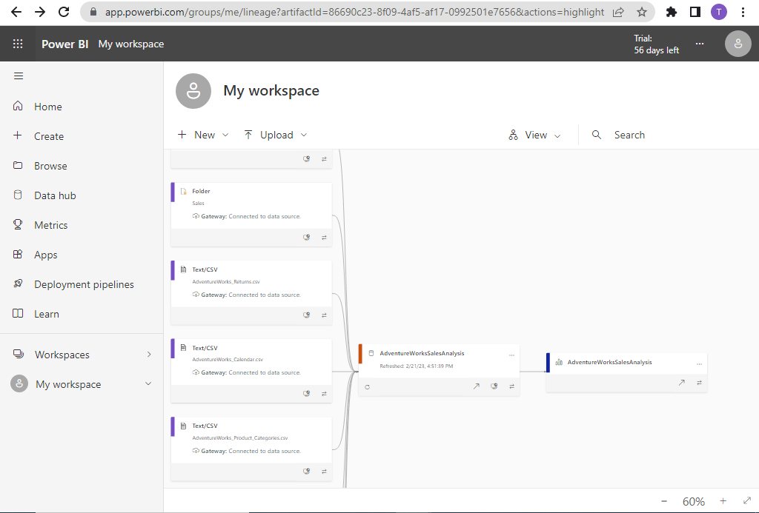

1. **Power BI Reports**
   * If you click the Power BI Pro workspace reports section, it will show up the Power BI Report we have created including all the different pages

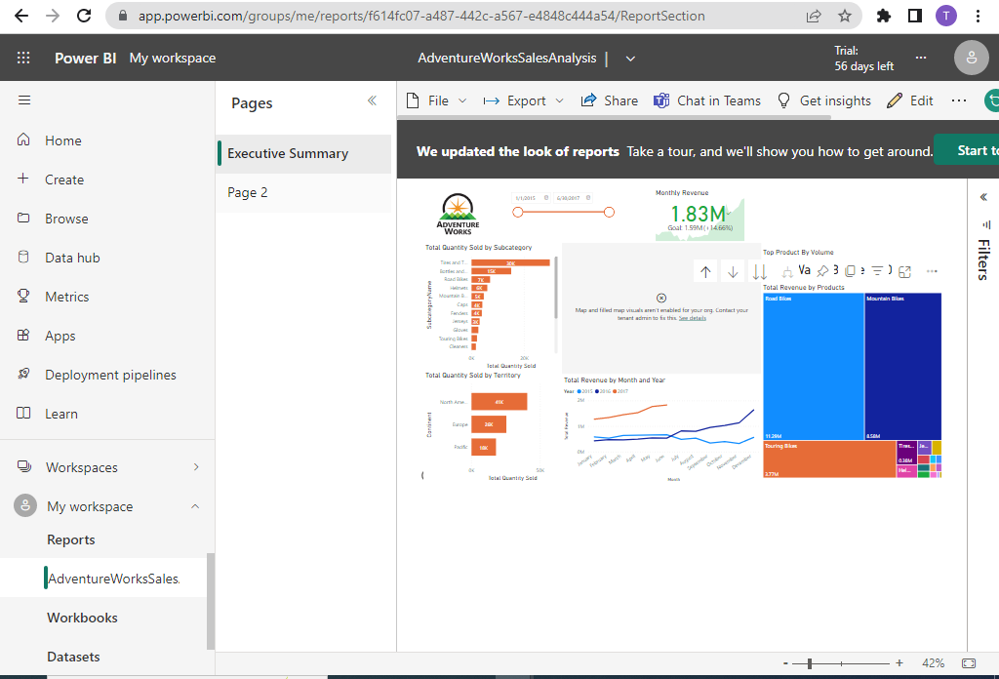

* + There are a lot of options available on top of the report page such as File, Export, and Share that allow expanding the use cases of reports.
  + Unlike Dataset we can create new reports and visualization within the Power BI Pro environment using edit Feature

1. **Edit** 
   * If you click the Power BI Pro workspace reports section, then click Edit you can edit and modify the existing reports with the edit view



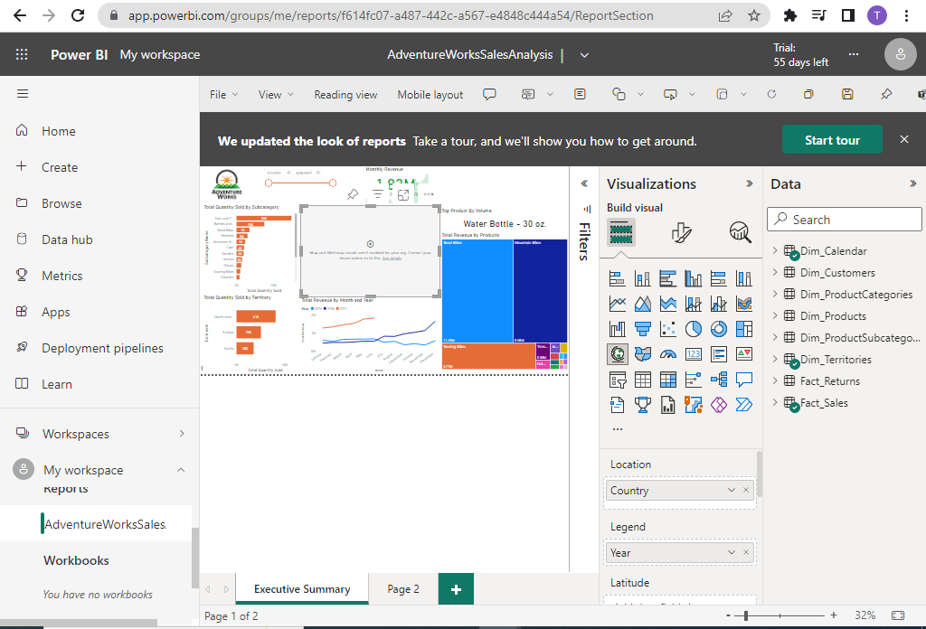

* + Here we can utilize almost every feature available in Power BI desktop reports in Power BI Pro as a test you can add a couple of cards and test with it
  + Also Here You can set up Mobile Report Layout for the Mobile phone user by clicking the mobile layout tab



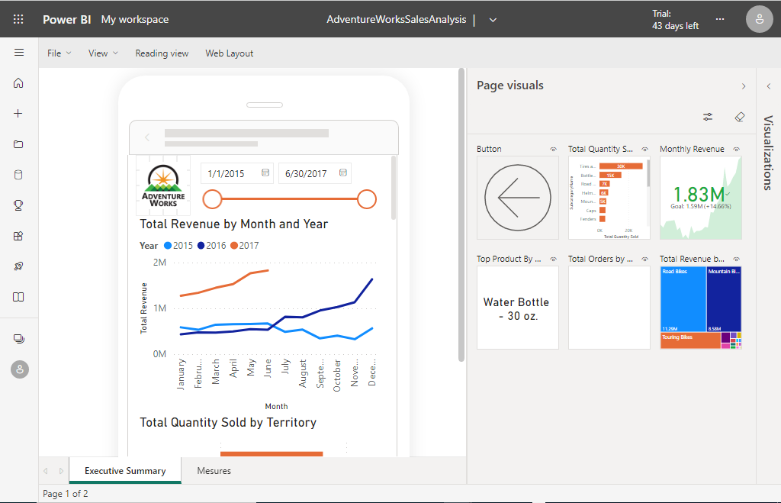

You can Move to the previous reading view by clicking the Reading View option next To Mobile/Web Layout



# **Understand and Create a Dashboard**

1. **What is the Power BI Dashboard?**
   * The Purpose of the Power BI dashboard is to provide a quick overview of important facts about your business or organization
   * This is a Power BI Pro-specific feature because of that it won’t be available in the Power BI Desktop
   * However, when you publish the Power BI Desktop project to Pro it will create an empty Dashboard, but if you connect Power BI Pro to the project you may not have a dashboard created for you
   * Anyway creating a dashboard is very easy. Go to My Workspace ->New->Dashboard
   * Name the dashboard and click Create button
   * This may take a few minutes to create a dashboard
   * 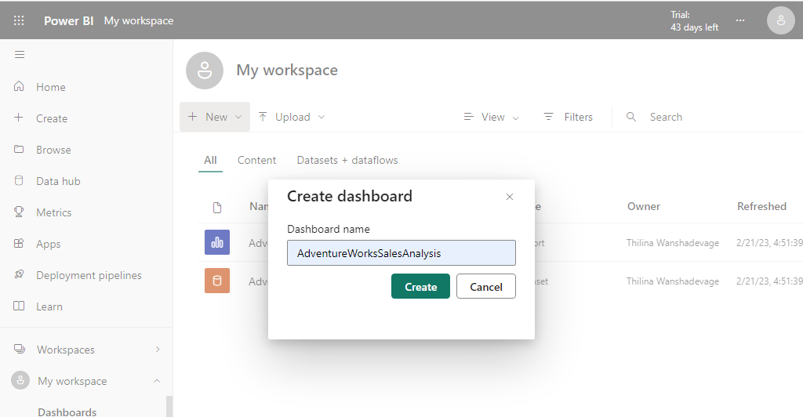

3

4

2

1

* + After creating the dashboard you will go to the following screen which is empty.
  + There is only an “Add” option available in Edit->Add Tiles using that we cannot add visualization created in the previous report

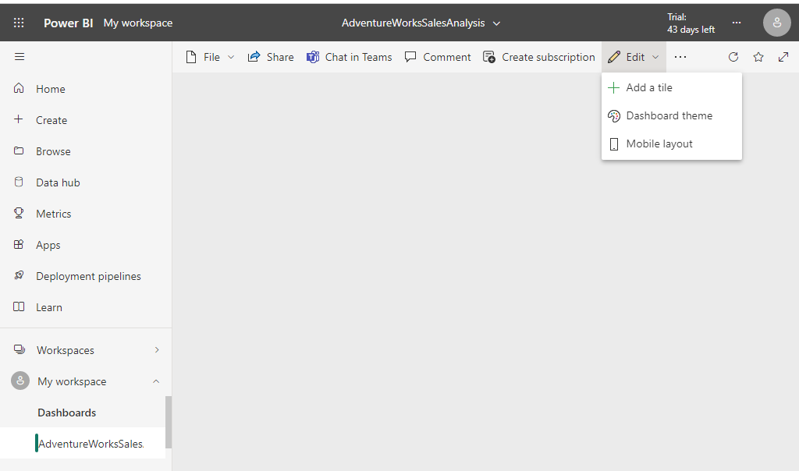

1. **Add Report Page to Power BI Pro Dashboard** 
   * To add the Report page to the dashboard first we need to go to My Workspace ->Report->

Select the Report Page -> ···-> pin to the dashboard

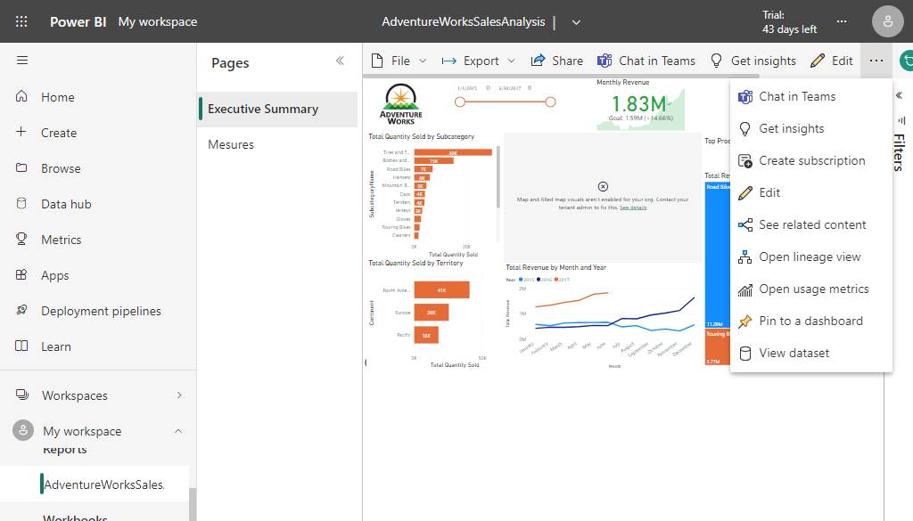

3

2

1

1

* + Next, you get the below dialog box from which you can select you want to pin the report on a new dashboard or existing dashboard and what dashboard you need to pin the report to and click the Pin live button
  + If you check the preview you can see this operation will pin the entire report to the dashboard

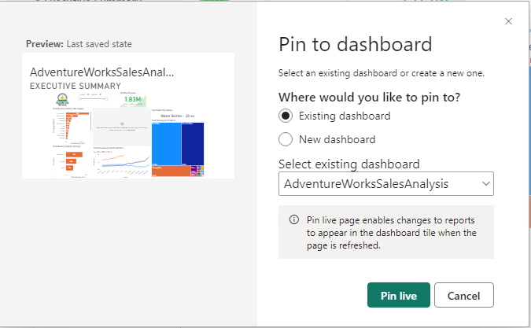

1. **Add Specific Visualization to the Power BI Pro Dashboard**
   * To add the Report page to the dashboard first we need to go to My Workspace ->Report->

Select the Report Page->Select Visualization->click on the Pin symbol on the top

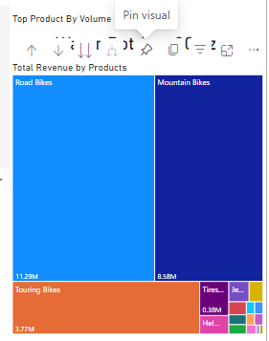

* + You will get the below form and fill it out accordingly and click Pin

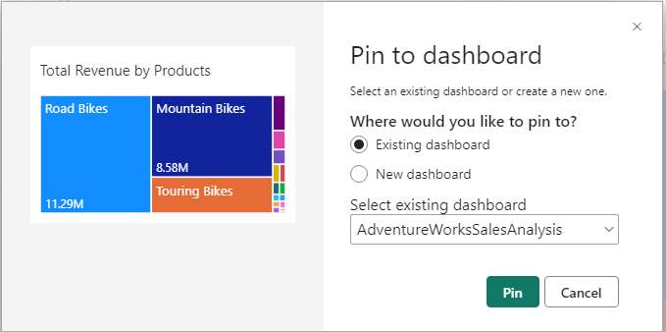

* + If you use a different theme in your dashboard you will get options to change or keep the current theme

# 

# **Gateways**

1. **Refreshing Dataset**
   * Go to My Workspace-> Datasets + Workflows->Refresh Now, the icon next to the dataset name might generate an error symbol

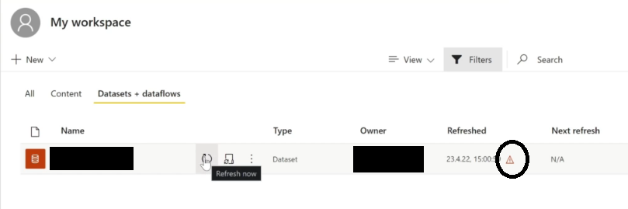

* + When you click the symbol you will get the following message

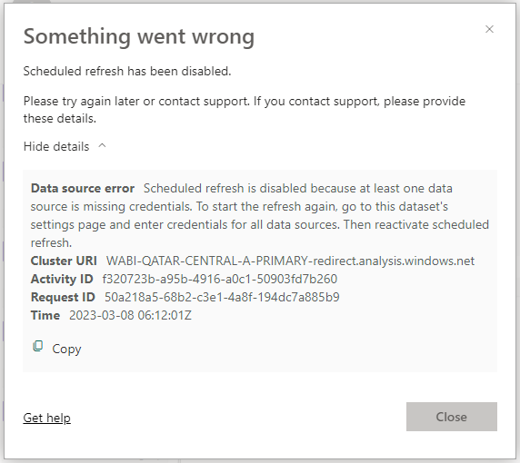

* + The reason for this issue is when we upload our project to Power BI Pro we upload Dataset and Reports only not the underlying dataset (Dataset contains the source file connections)
  + This means Power BI Pro Dataset+ Reports + Dashboard is operating as a separate entity and the underlying data file operates as a separate entity. Because of that any changes that happen to the data will not reflect on the Pro to make that happen we need to set up Gateway.

1. **Power BI Gateway**
   * If you check the Linage view you can see the content of the Power BI Desktop is uploaded into Power BI Pro which is a cloud service, But the data source files are still in our local computer or organization server the purpose of the Gateway is setting up the connection between data sources and Power BI Pro.
   * There are two types of gateways based on the location of data available
     1. Personal Gateway: If data is available on your local PC
     2. Standard Gateway: If data is stored in organization servers
   * Before we proceed go to the following link to download Power BI Personal Gateway

<https://powerbi.microsoft.com/en-us/gateway/>

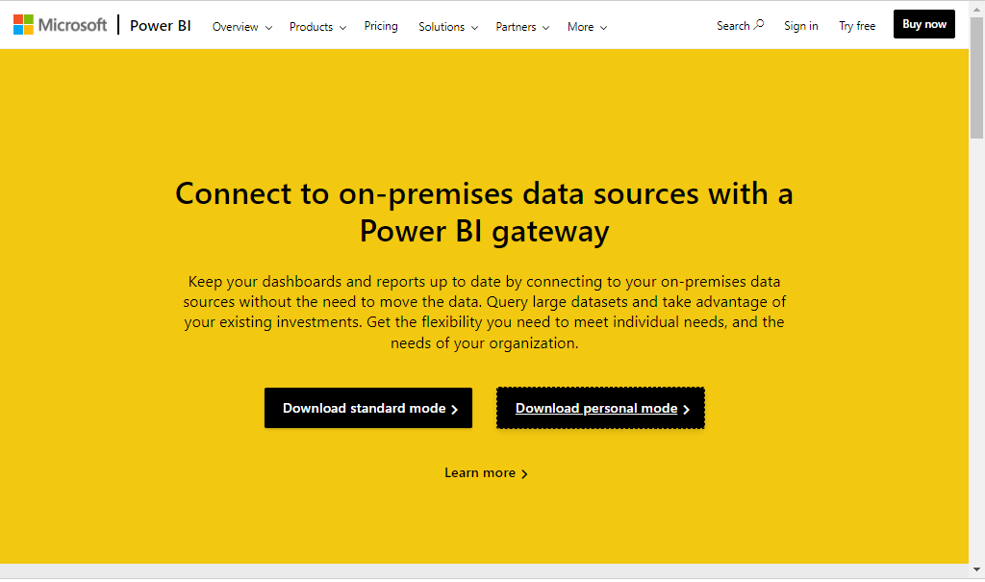

1. **Configuring Gateway** 
   * Download the personal gateway and install it and open Gateway
   * Register it with your Power BI Pro Email address
   * After installing and registering the gateway go to Power BI Pro and Click ··· next to profile ->Settings->Settings->Datasets->Select AdventureWorksSalesAnalysis if you have multiple Datasets

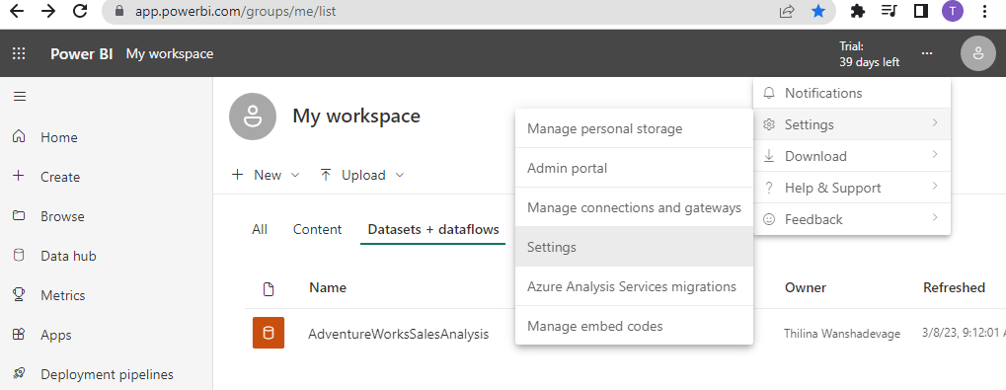

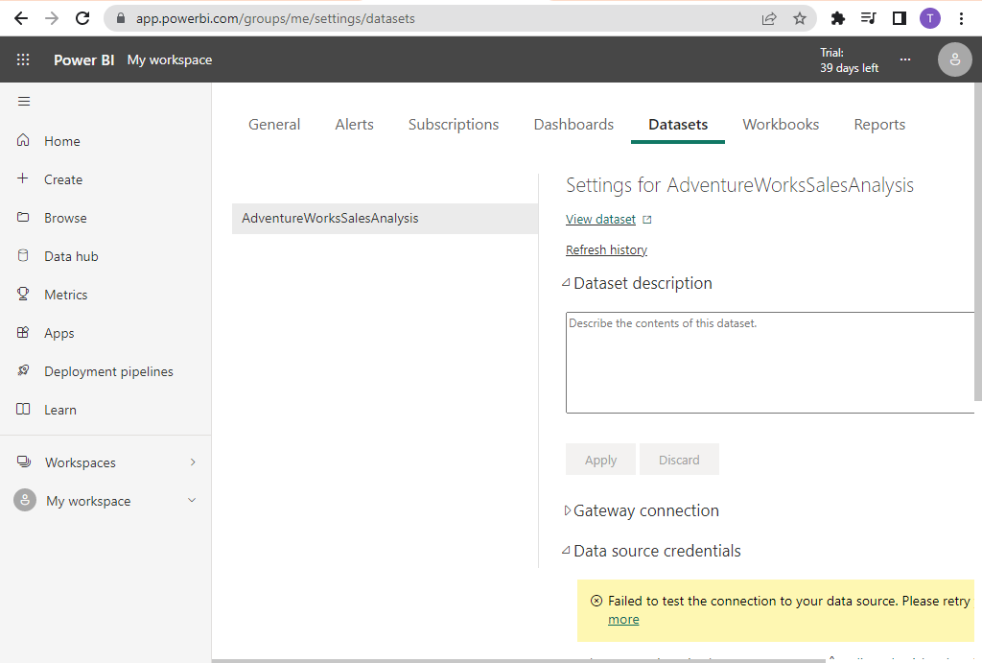

* + **When you click and expand the Gateway Connection It will show Following**

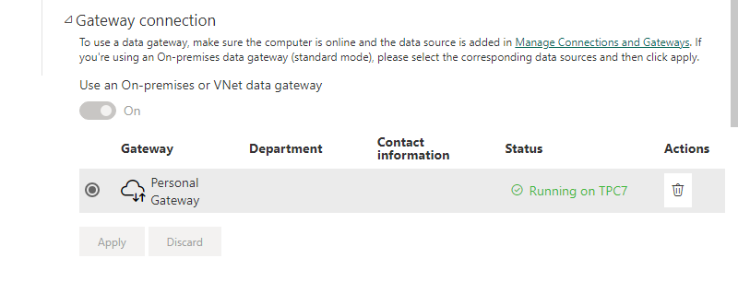

* + **Since we installed the gateway before we can see in the status Up and running Gate way available**
  + **If you click Manage Connection and Gateways you can see the status of the gateway on the home page**
  + **The next important part is right below the Gateway connection you can see credential issues if your gateway is up and running you simply click the Edit credentials and set up the credentials by clicking sign in button on the form**

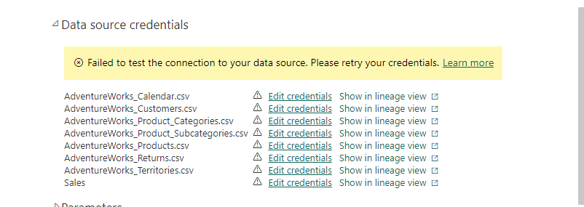

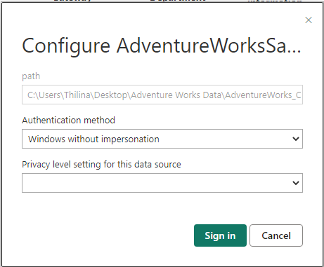

* + **If you get below confirmation that mean your credentials is working**

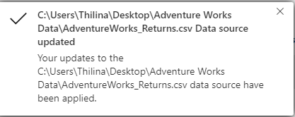

* + **After all source file credentials are updated go to my workspace->Dataset->Refresh Dataset. This may take a few minutes**
  + **If you check My Workspace you can see our dashboard is not refreshed. To refresh the dashboard Expand the My Workspace and open Dashboard and Click the refresh button at the right upper corner**

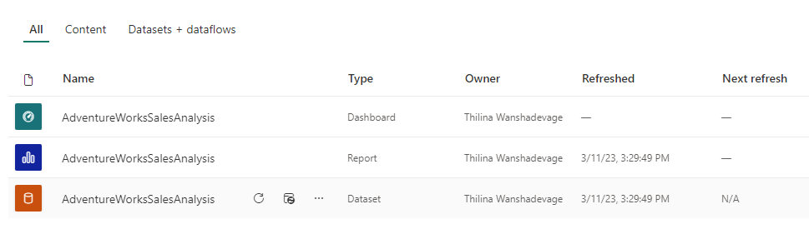

1. **Automatic Refresh** 
   * **To set up Automatic Refresh go to Power BI Pro and Click ··· next to profile ->Settings->Settings->Datasets->Select AdventureWorksSalesAnalysis->Expand Scheduled Refresh and switch on and set up as see fit and click Apply**

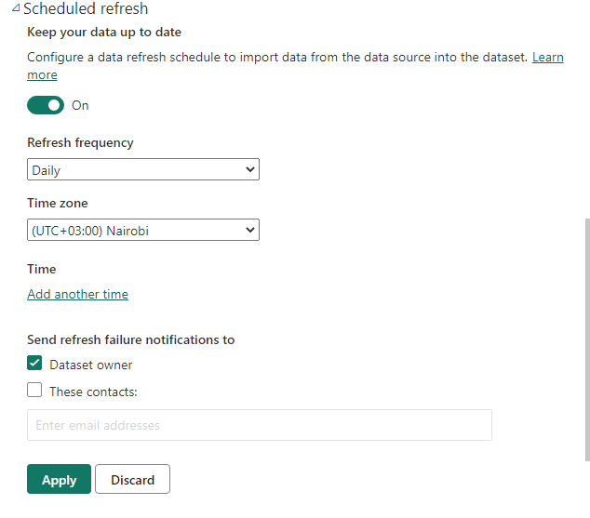

# **Sharing Knowledge with Workspaces**

1. **Sharing Knowledge with Power BI Pro**
   * The knowledge is useless if it cannot utilize or share with relevant people. The main purpose of Power BI Pro is to make sure the knowledge you have gained from analyzing data on the Power BI Desktop reaches the people who required those insights
   * With Power BI Pro to achieve this we have Power BI workspaces. We have seen a couple of places we can share our knowledge as shown below.
   * Please note in the time of preparation of this Power BI Pro went through a major update and now the screens are a little different from the previous screens
2. **Share Dataset with Direct Access** 
   * As I explained before Power BI Pro went through a major update and there are a few changes happened in the My workspace
   * To share a dataset, go to My Workspace->Select Three Dots->Manage Permission

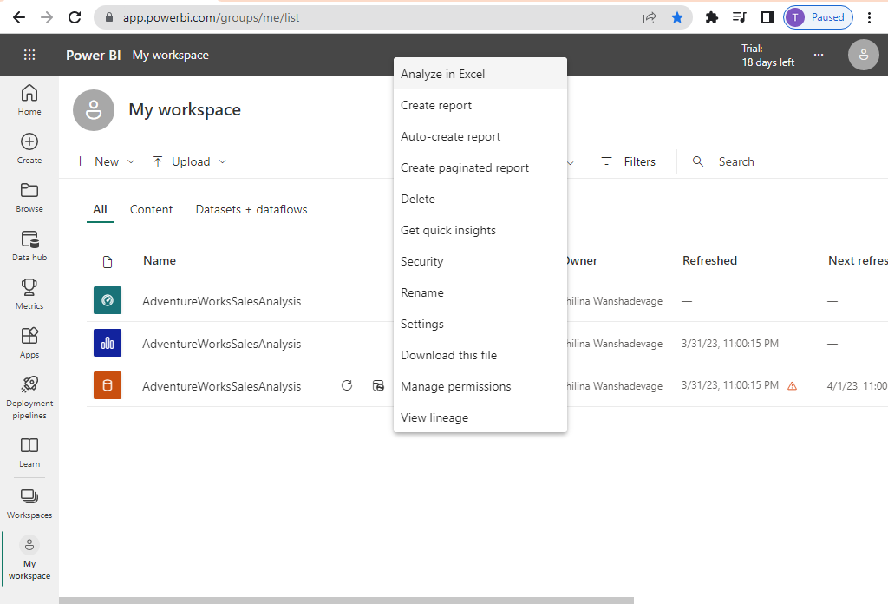

* + Then click Add User

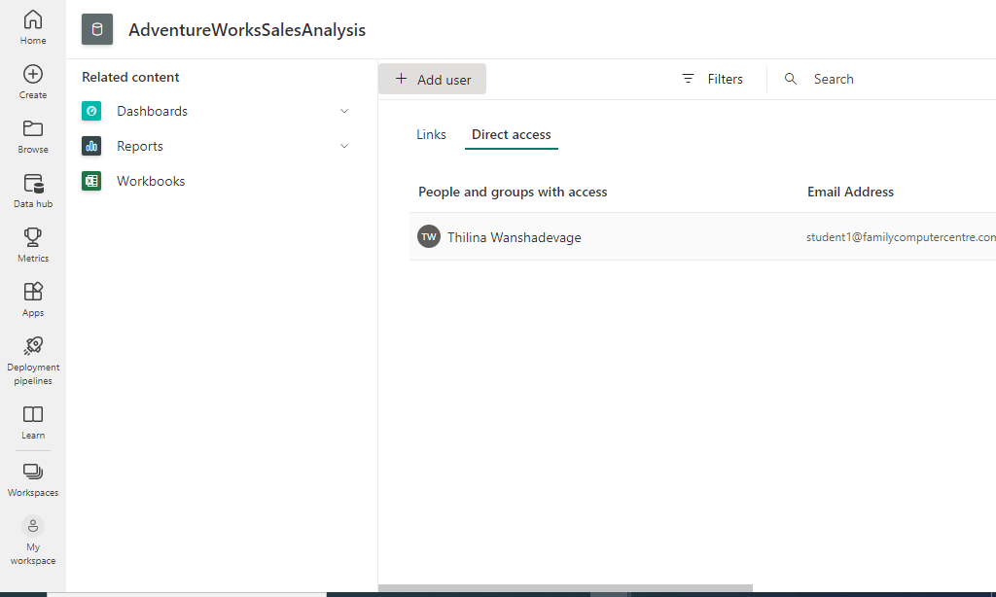

* + Fill up the email addresses or names of users you wish to grant access to the dataset make sure to select appropriate privileges when you grant access to other use

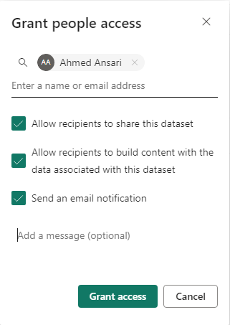

* + If successful, you will see newly granted users will appear on the direct access page

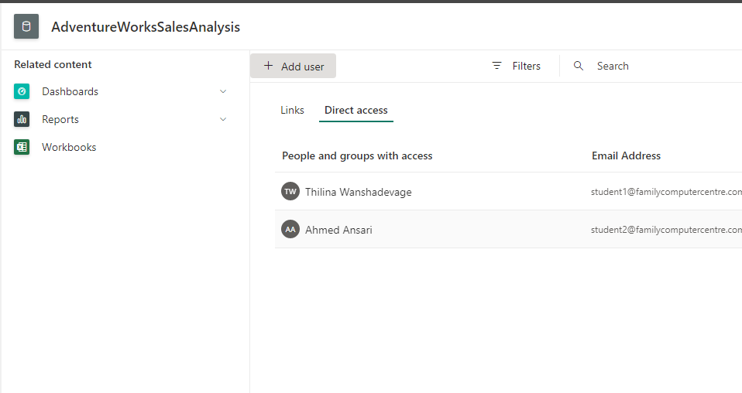

* + After granting access new users can access the published dataset via the Data hub option in Power BI Pro from there you can create necessary reports and dashboards.

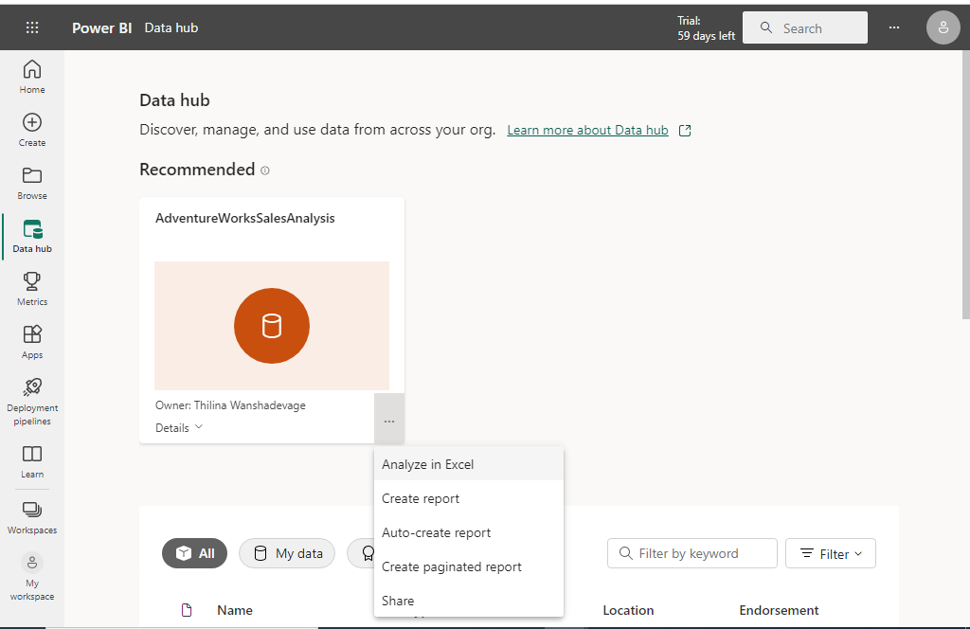

* + If the user creates a report and saves it using a shared dataset now newly created report is available in his workspace

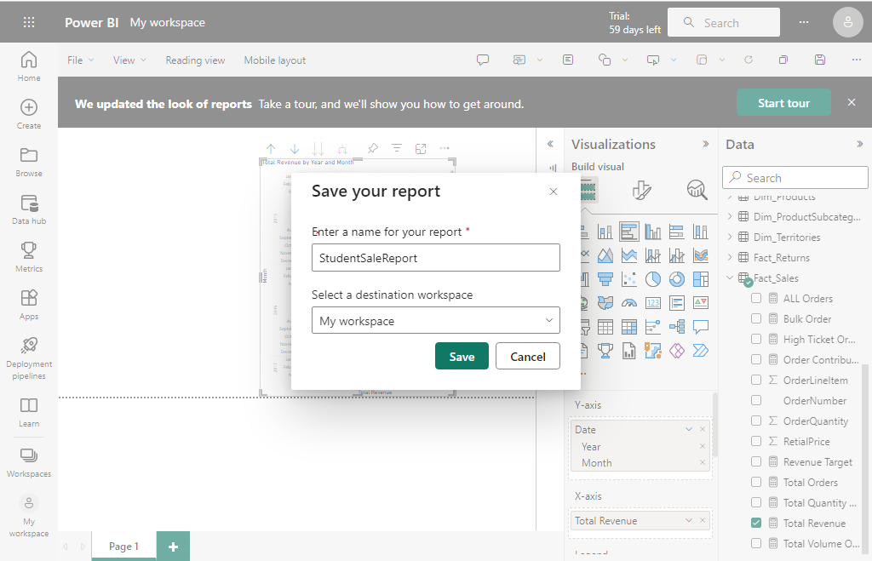

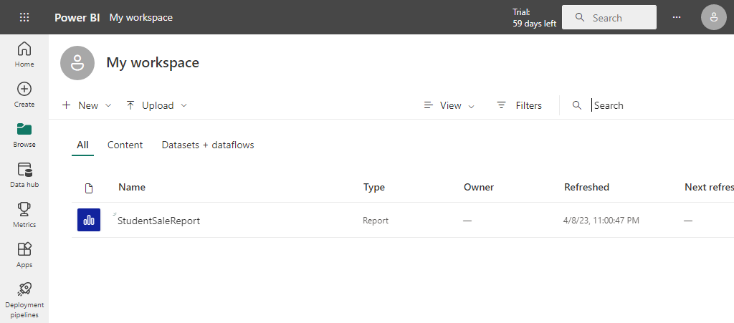

* + If you remove access to the dataset you must log in to the system as dataset owner and go to my workspace->Dataset+Dataflow->Select Three dots->Manage Permission->Direct Access ->Remove Access

1. Share Dataset using the link
   * Links are specifically created for sharing Power BI reports with other users. We cannot share datasets with links for that we need to use the direct access method
   * To share reports using links first go to my workspace->Click three dots in report->Manage permission.

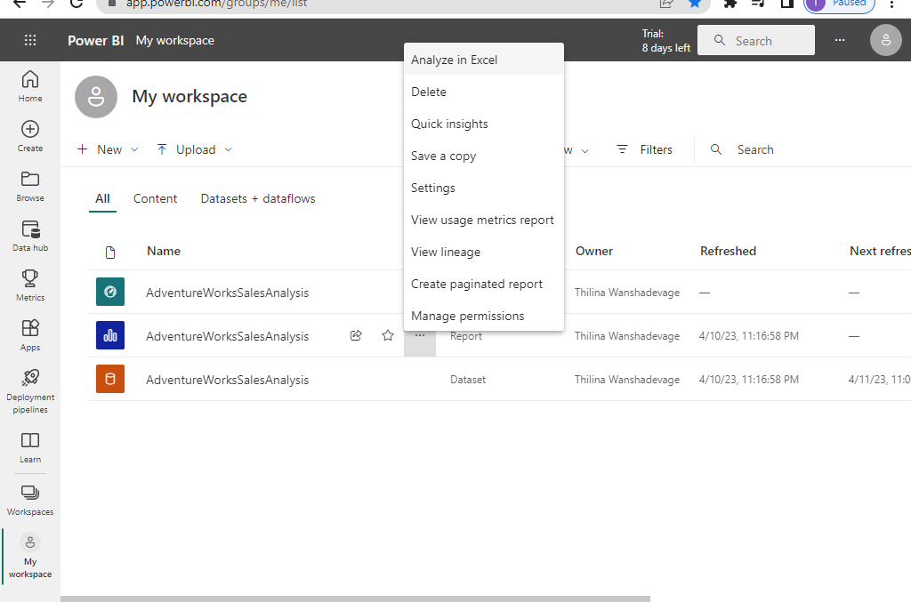

* + Click Link Tab->Add link in the form and

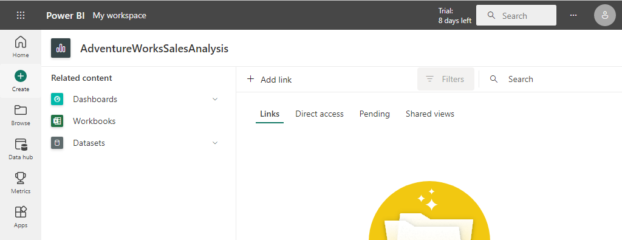

* + After filling out the below form we can share the generated link You can click Learn More link to further check the options

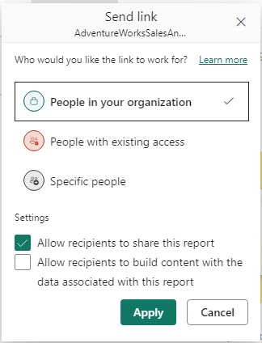 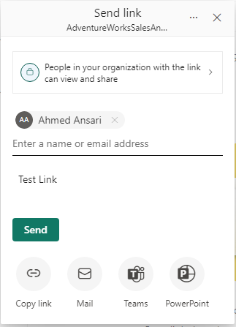

* + When you click send you will get the below message

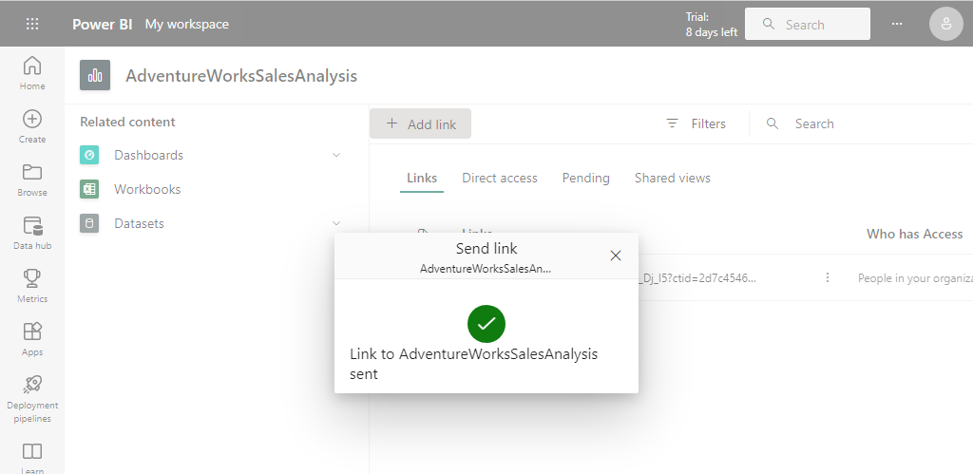

# **Collaboration Workspace**

1. Introduction
   * Collaboration workspace helps organizations to work collaboratively with multiple peoples
   * This is a very effective method if you are running a data science project and you need to involve various people in to project for their expertise
   * To create a collaboration workspace, Click Workspace ->New workspace ->Give Name and Description and click Save

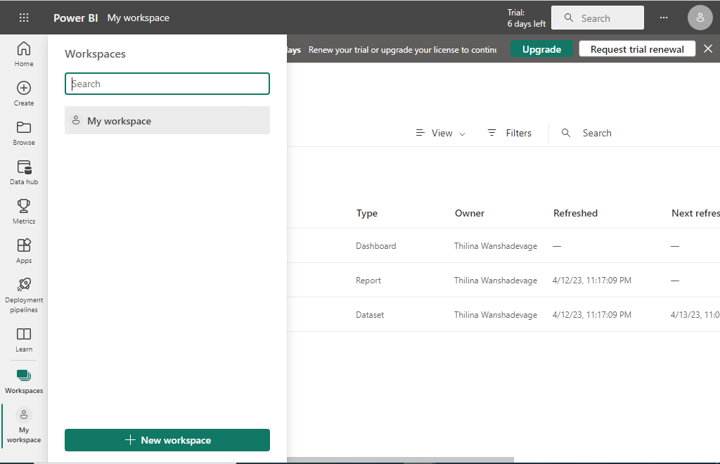

* + You are not limited to one workspace you can create many workspaces per each project as needed

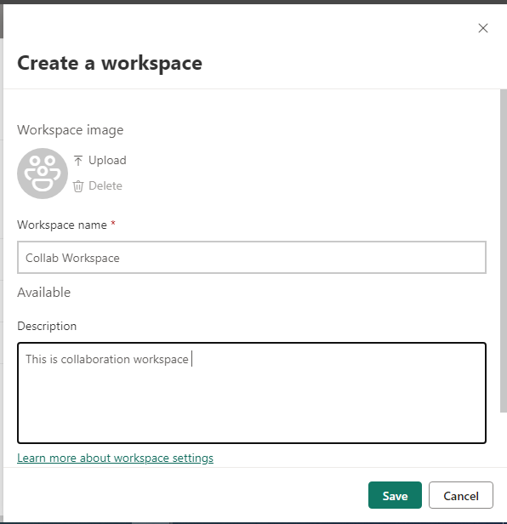

* + After you have created the workspace you can give access to other users within your organization by Clicking Access on the page

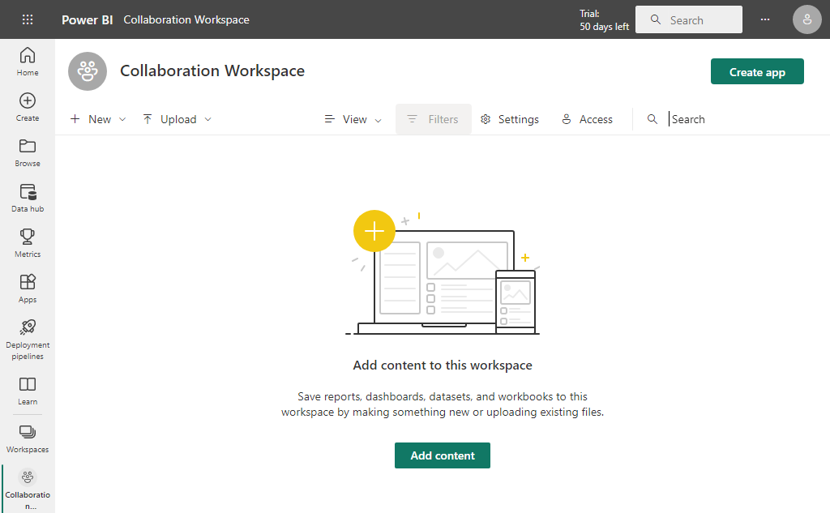

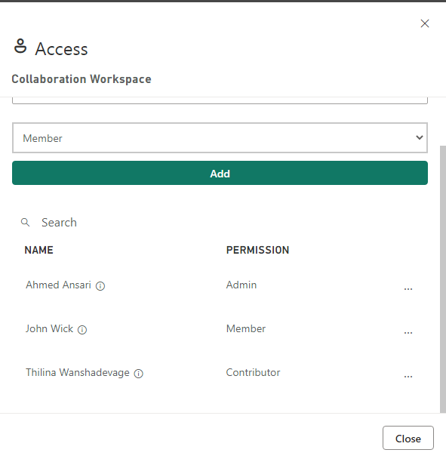

1. Why Collaboration workspace
   * How this is different from the previous share dataset or report in the previous example
   * The advantage of using this shared space feature is you can easily collaborate with people in your organization with data project
   * So each collaboration workspace can act as a separate data project and you can manage access and share resources with the project stakeholders easily while maintaining personal workspace separately
   * Let’s see how we can do it
   * We already have a collaboration Workspace let's add the project we created using the Power BI desktop to the workspace, By Upload-> Browse-> Select .pbix file from the local drive

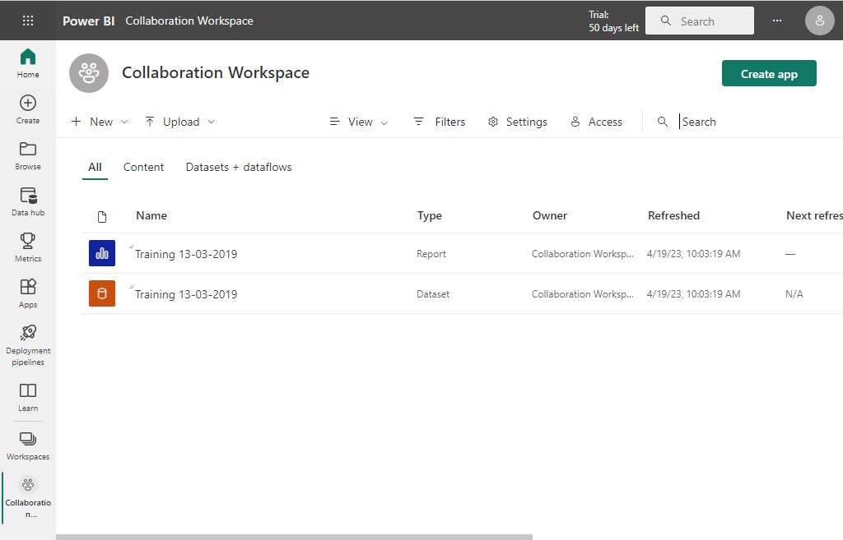

* + This Workspace was created by User Ahmed see how it will show up in John’s Login after we add him as a member of this project

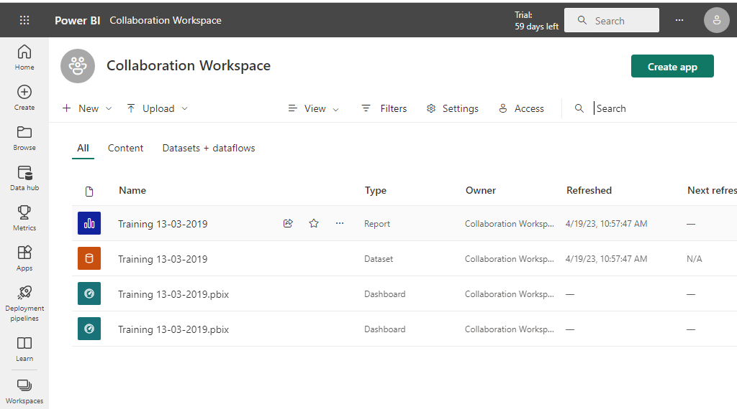

* + So he can use the data model and existing report to create the dashboard. To do that you can go to report and select existing visualization and click Pin Icon in the visualization

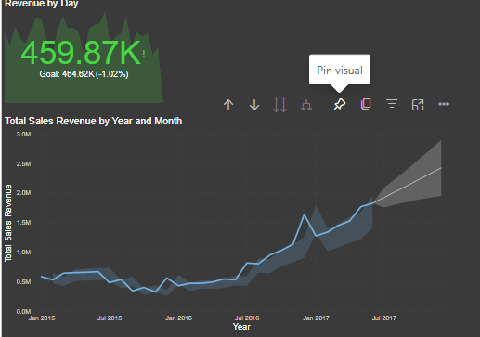

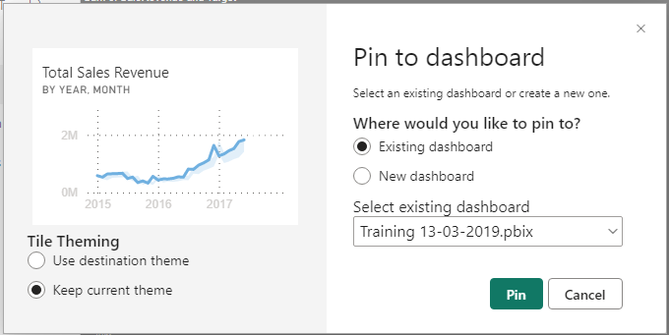

* + When you click The Pin you can see the visualization on the dashboard you have selected

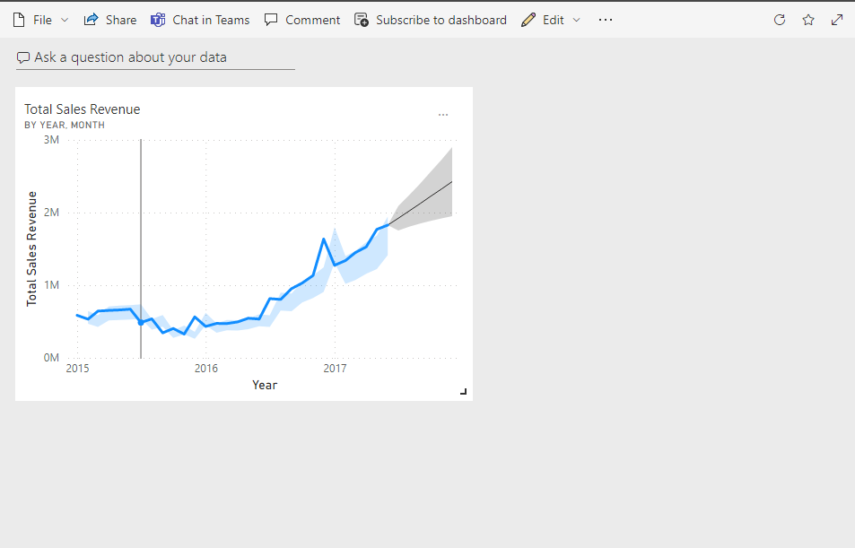

* + If you access this workspace with another user's account and you can see the same.
  + If the user is completed his or her work in the project and no longer needs access to the project owner or admin can easily remove access by clicking Access->Three Dots next to the user->Remove

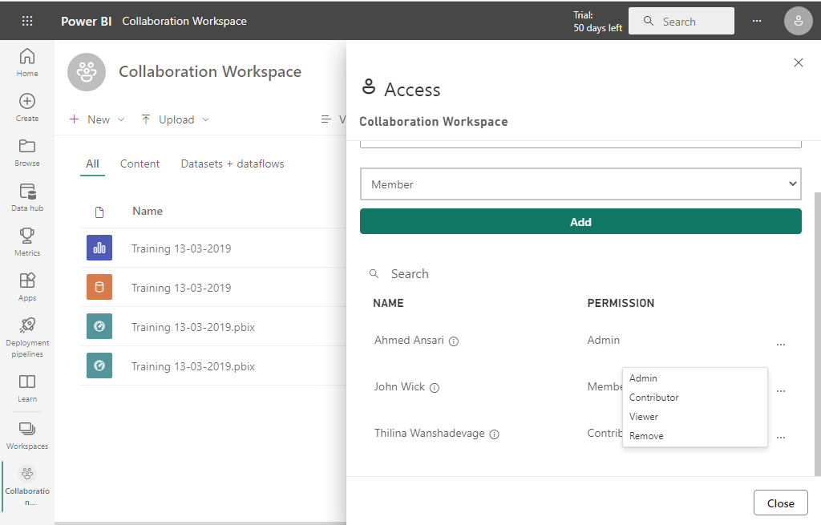

# **Sharing with Apps**

1. **Power BI Pro Apps Introduction**

* If we need to share data inside the collaboration workspace another way of doing that is using Apps
* With Apps, we can nicely package the content of the collaboration workspace that fitting to the audience information requirement
* In the past, this feature was named a content pack
* This is a wonderful way of sharing data using Power BI Pro with highly customize accessibility

1. **Create App** 
   * Go to your shared workspace (In our case we named it as collaboration workspace) and click the create apps button

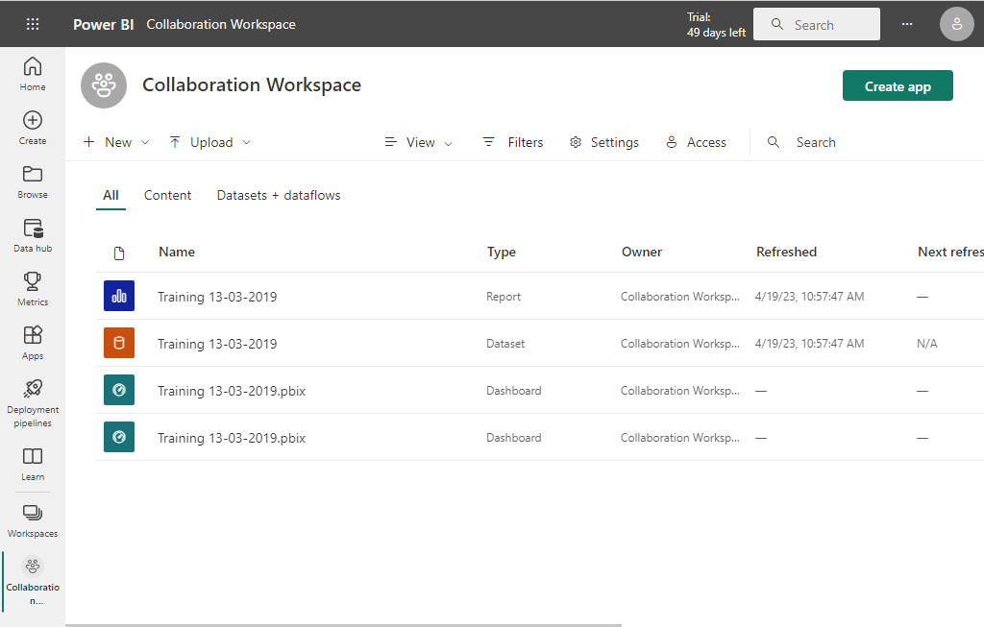

* + Create a suitable name and description for the app. The creation form is pretty intuitive follow the instructions you will manage

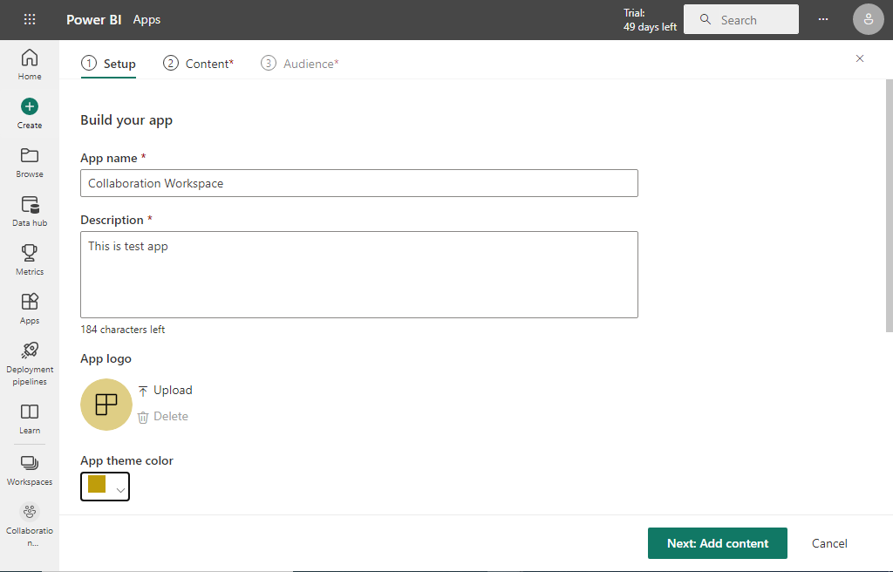

* + Click the Next Add content button in the next form and select the report or dashboard you wish to share

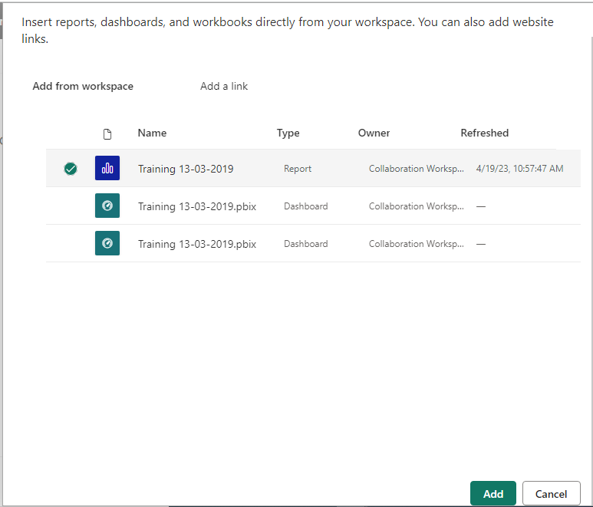

* + Click Add Button, Then Add Audience Button to move next part of the process and fill in the peoples email you wish to share the app or select the entire organization Then click Publish app Button

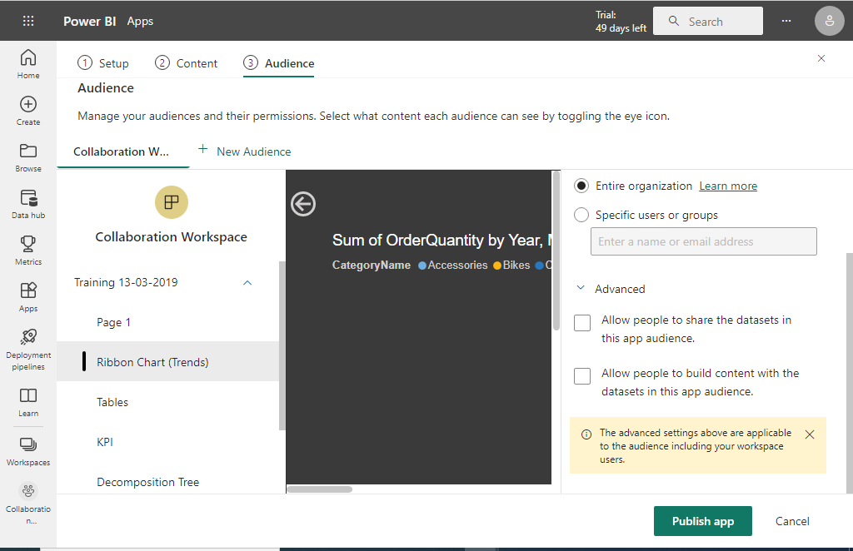

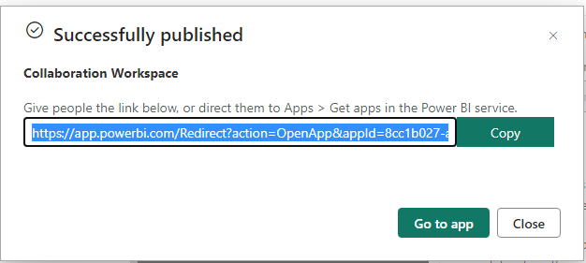

1. **Get An App** 
   * To get the shared app you can directly access the app using the above link and also you can go to Apps. Then Get Apps

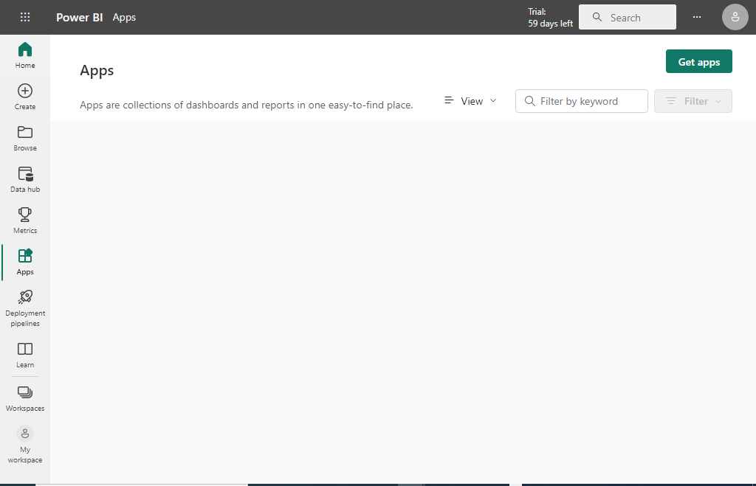

* + Then in the newly loaded form click organization you can see the apps that you have access to create by your organization. Click Get it now

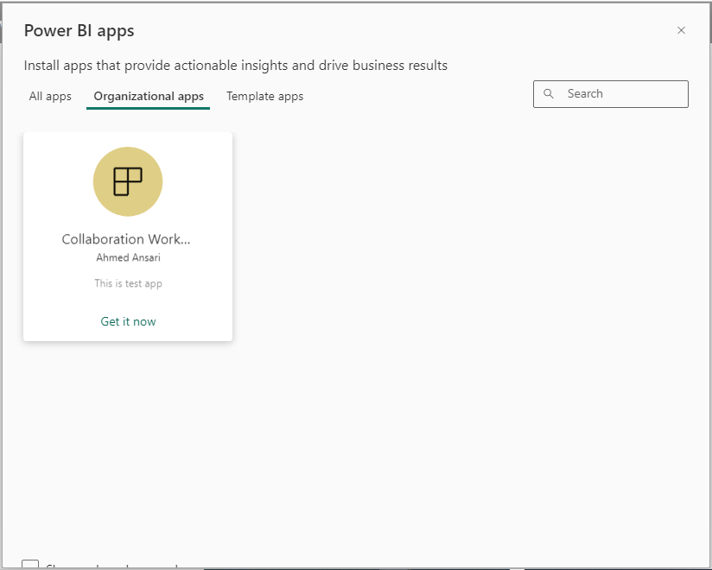

* + Click Get it now and wait until the app is installed. After that, you will go to the below page

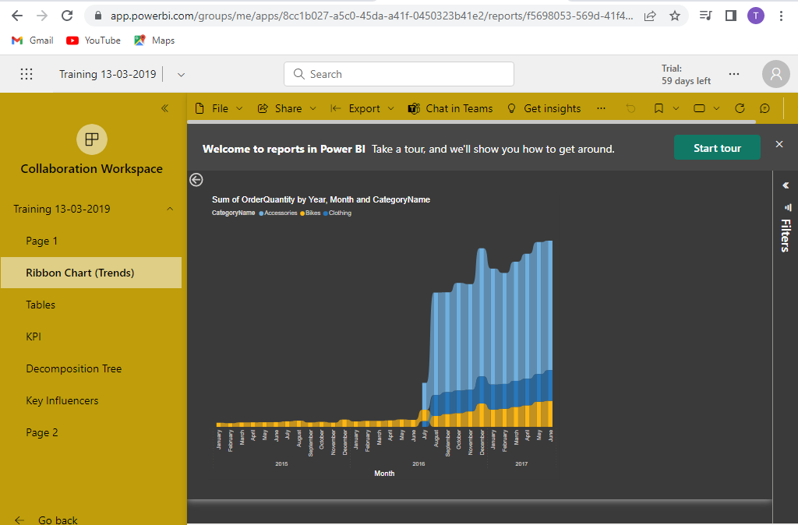

* + The app is now a dedicated environment in Power BI Pro not associated with the workspace If you go back to your Pro-Environment and click the app menu you can see that app is available in the

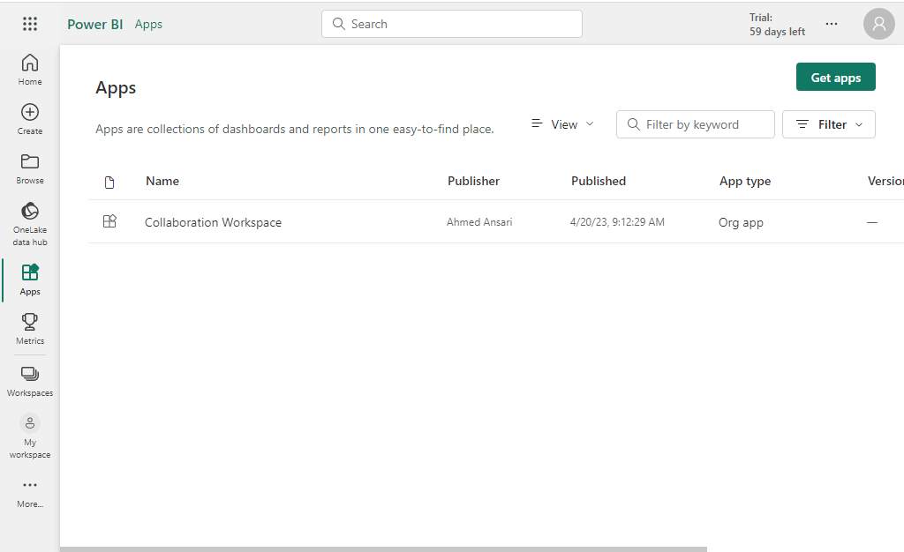

1. **Create New Reports via the app**
   * If the Publisher allowed other users can use a dataset of the app user can create his or her reports.
   * First You have to click three dots and select View Dataset

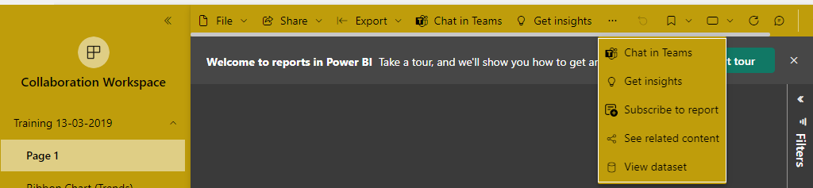

* + If the App publisher allowed other users to modify the app you can create a report and you can pick auto-create for this demo

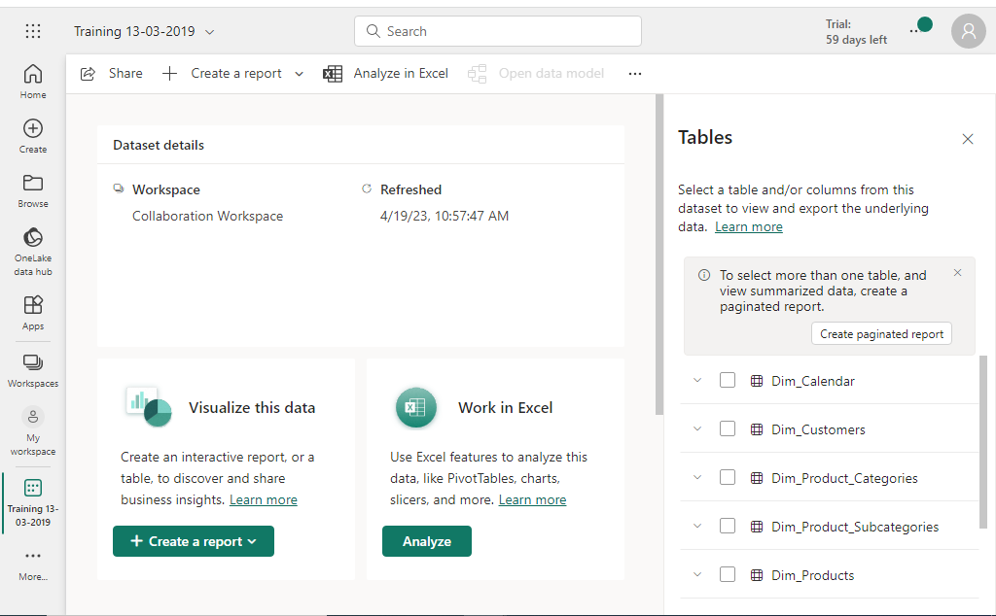

* + After Creating the report, you can save the reports in your workspace or collaborative workspace by clicking Save Button

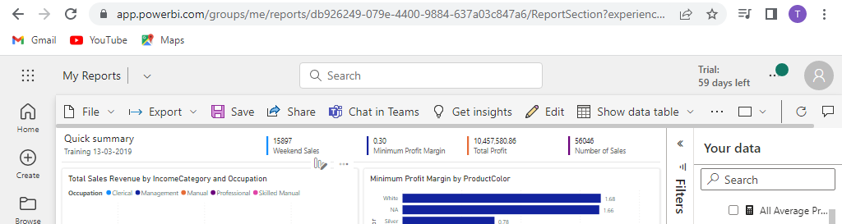

1. **Unpublish App**
   * Go to the Workspace where you have created the App, Then Click The three dots in the workspace and select Unpublish App

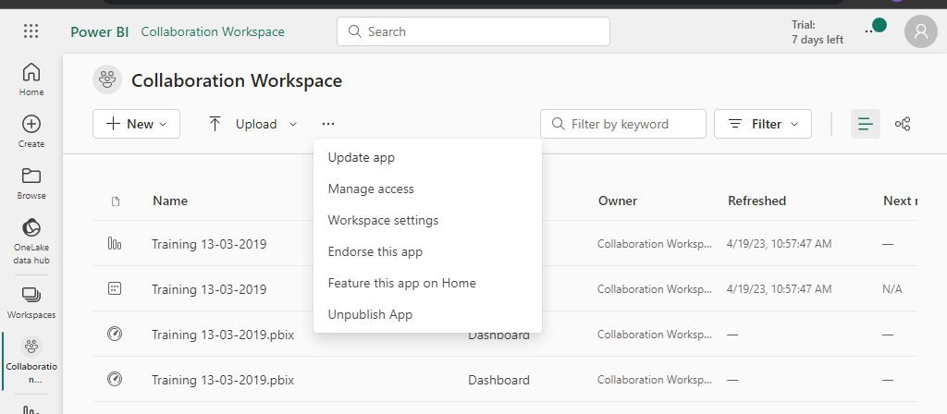

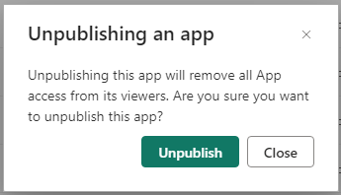

* + Click the Unpublish button and then check the App menu->Get App or Downloaded apps and observe that Collaboration Workspace Apps is gone

1. **Conclusion**
   * We do have multiple options when working with Power Bi Pro such as My Workspace, Workspace, and Apps. Let’s find out what option is suitable for the situation

* + My Workspace

This is the workspace for single developers in the Power BI Pro environment. You can work on your project with a Power BI Desktop and you upload that into a Pro environment to access anywhere in the world. This is your personal workspace instance in Power BI Pro and you can grant access to other people in the organization as you see fit

* + Workspace

This can space is the multi-developer environment of the Power BI Pro. Developers can work collaboratively on the same project and we can control access on an as-needed basis by granting and revoking access

In addition to that this workspace also have App feature that allows us to convert the project to an app and publish and unpublish it for the end users

* + App
  + With Apps, we can share our Findings, analysis, and underlying data with end-users or specific parts with end-users. This end user could be an organization executive, manager, or anyone within your organization

# **Power BI Mobile App**

1. **Introduction**
   * In addition to Power BI Pro Power BI Mobile is a dedicated mobile app that allows you to access Power BI projects via Mobile devices
   * You can find this app in the Google play store or Apple Appstore. So Download and install it on your Mobile device.
   * When you open the app you can switch between the report server and Power BI
   * Select Power BI and use credentials to log in to Power BI